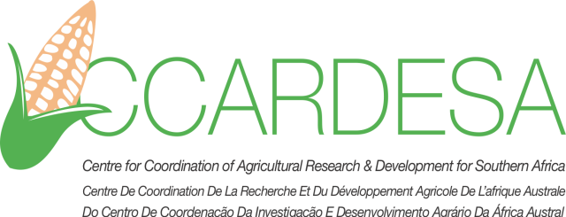

**Curriculum vitae**

1. **Family name: PONGUANE**
2. **First names: Sérgio**
3. **Nationality: Mozambique**
4. **Country of Residence: Mozambique**
5. **Contact details:** [ponguane@yahoo.com.br](mailto:ponguane@yahoo.com.br)

**+258 840166546**

1. **Education:**

|  |  |
| --- | --- |
| **Institution**  **[ Date from - Date to ]** | **Qualification obtained:** |
| Egerton University, Kenya  August,2014- December, 2016 | MSc Agricultural Economics |
| Univeristé de Blida, Algeria  September, 2005-July,2011 | BSc (Hons) Agronomy with specialization in Agricultural and food economics |
|  |  |

1. **Language skills:** (1 - excellent; 5 - basic)

|  |  |  |  |
| --- | --- | --- | --- |
| **Language** | **Reading** | **Speaking** | **Writing** |
| Portuguese | 1 | 1 | 1 |
| French | 1 | 2 | 2 |
| English | 1 | 2 | 2 |

1. **Membership** **of professional bodies:**

|  |
| --- |
| African Association of Agricultural Economists  African Growth and Development Policy Modeling Consortium (AGRODEP) |

1. **Specialisation**: agricultural economics
2. **Present position:** Lecturer and researcher in agricultural economics at the Instituto Superior Politécnico de Gaza (ISPG), Mozambique
3. **Key Skills:** Qualitative and quantitative Methods including mastery of computer software (Stata, SPSS, Gretl and Microsoft office) and Basic Knowledge of GAMS, Logframe matrix
4. **Specific experience:**

|  |  |
| --- | --- |
| **Country** | **Date from - Date to** |
| Mozambique | 2012-Ongoing |
| Mozambique and Zimbabwe | 2019-Ongoing |
|  |  |

1. **Professional experience (Formal employment and Assignments/consultancies**)

| **Date from - to** | **Location** | **Organisation** | **Position** | **Description of Duties and achievements** |
| --- | --- | --- | --- | --- |
| 2019-ongoing | Mozambique and Zimbabwe | IHE, Delft and ISPG | Project Coordinator | Coordinate activities related to applied research on women empowerment through sustainable resource use and agricultural value chain development along the Limpopo basin  (Ongoing) |
| 08 June-15 August | Mozambique | IFPRI | Collaborator | Conduct a diagnostic survey on Systems of Grades and Standards in Mozambican Agriculture  Ranked among the top 5 out of 40 countries |
| December, 2018-March, 2019 | Mozambique | IPSAR Project | Consultant | Socio-economic feasibility study for the implementation of Irrigation Package for Sand Rivers (IPSAR) Project |
| 1, February-15, March | Mozambique | IFPRI | Collaborator | Produce a policy brief on prevention of food loss in African value chain  (ongoing) |
|  |  |  |  |  |

1. Publications

A.E.C. Duker, C. Cambaza, P. Saveca, **S. Ponguane**, T.A. Mawoyo, M. Hulshof, L.S.Nkomo, S.W. Hussey, B. Van den Pol, R. Vuik, T. Stigter, and P. Van der Zaag. (2020): Using nature-based water storage for agriculture in African drylands: lessons from frugal innovation pilots in Mozambique and Zimbabwe. Environmental Science and Policy, Special Issue Water Innovations in Africa. doi.org/10.1016/j.envsci.2020.02.010

**Ponguane, S. &** Mucavele, N. (2018). Determinants of Agricultural Technology Adoption in Chókwè District, Mozambique. The IJHSS Vol (6) Issue 4. Available in Repec/MPRA

**Ponguane, S.,** Mucavele, N., & Mussumbuluco, B. (2021). Land Grabbing or Rice sector development opportunity?. African Journal on Land Policy and Geospatial Sciences, 4(3), 343-353. [doi.org/10.48346/IMIST.PRSM/ajlp-gs.v4i3.22992](https://doi.org/10.48346/IMIST.PRSM/ajlp-gs.v4i3.22992)

**Ponguane, S.** (Under Review). Prevention of Food losses along the value chain in Africa. Evidence-based good practices. *Food Security Portal*

1. **Professional Referees**

**Carlos Balate, PhD**

**Deputy General Director at ISPG**

[carlos.balate@ispg.ac.mz](mailto:carlos.balate@ispg.ac.mz)

**Cesario Cambaza, MSc**

**Lecturer at ISPG**

[cesario.cambaza@ispg.ac.mz](mailto:cesario.cambaza@ispg.ac.mz)